**Home equity lines of credit in U.S banking sector**

Home Equity Lines of Credit (HELOCs) are a significant component of consumer lending in the U.S. banking sector. They allow homeowners to borrow against the equity in their homes, providing a flexible source of funds for various needs such as home improvements, debt consolidation, or major expenses.

1. **Definition**:
   * A HELOC is a revolving line of credit secured by the borrower's home. Borrowers can draw funds up to a certain limit, repay, and borrow again during the draw period.
2. **Terms**:
   * **Draw Period**: Typically5-10 years, during which borrowers can access funds and make interest-only payments.
   * **Repayment Period**: Typically10-20 years, during which borrowers repay both principal and interest.

**Key Players**

1. **Commercial Banks**
   * **Wells Fargo**: Offers HELOCs with competitive rates, flexible terms, and online account management.
   * **Bank of America**: Provides HELOCs with variable and fixed-rate options, plus interest rate discounts for existing customers.
   * **Chase Bank**: Offers HELOCs with various borrowing limits and repayment terms, along with online management tools.
2. **Credit Unions**
   * **Navy Federal Credit Union**: Provides HELOCs with no application or origination fees, targeting military members and their families.
   * **PenFed Credit Union**: Offers competitive rates and flexible borrowing options for HELOCs.
3. **Mortgage Companies**
   * **Quicken Loans (Rocket Mortgage)**: Provides HELOCs with a focus on streamlined online applications and quick approvals.

**Market Trends**

1. **Interest Rates**:
   * HELOC interest rates are typically variable and tied to the prime rate. They have been influenced by changes in the Federal Reserve’s interest rate policies.
   * Fixed-rate options are also available, offering stability in repayment amounts.
2. **Home Equity Utilization**:
   * Homeowners have increasingly used HELOCs as home values have risen, providing more equity to borrow against.
   * HELOCs are often used for home improvements, debt consolidation, education expenses, and emergency funds.
3. **Regulatory Environment**:
   * Lenders must comply with regulations set by the Consumer Financial Protection Bureau (CFPB) and other agencies to ensure fair lending practices and transparency.
   * The Truth in Lending Act (TILA) requires clear disclosure of terms and costs associated with HELOCs.

**Management Strategies**

**Lenders' Strategies:**

1. **Risk-Based Pricing**:
   * Adjust interest rates based on the borrower's credit score, loan-to-value ratio, and overall risk profile.
   * Offer discounts for automatic payments and for customers with existing relationships.
2. **Flexible Products**:
   * Provide both variable and fixed-rate HELOC options.
   * Allow for interest-only payments during the draw period to make it more affordable for borrowers initially.
3. **Technology Integration**:
   * Use online platforms for application processing, account management, and customer service.
   * Implement automated underwriting systems to speed up approval processes.
4. **Credit Management**:
   * Regularly review and adjust credit limits based on changes in home values and borrower credit profiles.
   * Offer financial counseling and resources to help borrowers manage their credit effectively.

**Borrowers' Strategies:**

1. **Rate Shopping**:
   * Compare rates and terms from multiple lenders to find the best HELOC product.
   * Consider both variable and fixed-rate options based on personal financial situations and market conditions.
2. **Financial Planning**:
   * Use HELOCs for strategic purposes such as home improvements that can increase property value.
   * Avoid using HELOCs for discretionary spending to prevent over-leveraging.
3. **Credit Management**:
   * Maintain a good credit score to qualify for better rates and terms.
   * Make consistent, on-time payments to manage debt levels and avoid penalties.

**Key Statistics**

1. **Interest Rates**:
   * HELOC rates are typically tied to the prime rate plus a margin. As of recent years, variable HELOC rates have ranged from 4% to 7%, depending on the borrower’s credit profile and market conditions.
2. **Market Size**:
   * The total outstanding balance of HELOCs in the U.S. has fluctuated over the years, reaching approximately $350 billion in recent times, reflecting the increased utilization of home equity for borrowing.
3. **Delinquency Rates**:
   * Delinquency rates for HELOCs have remained relatively low, often below 2%, indicating that borrowers generally manage these lines of credit responsibly.

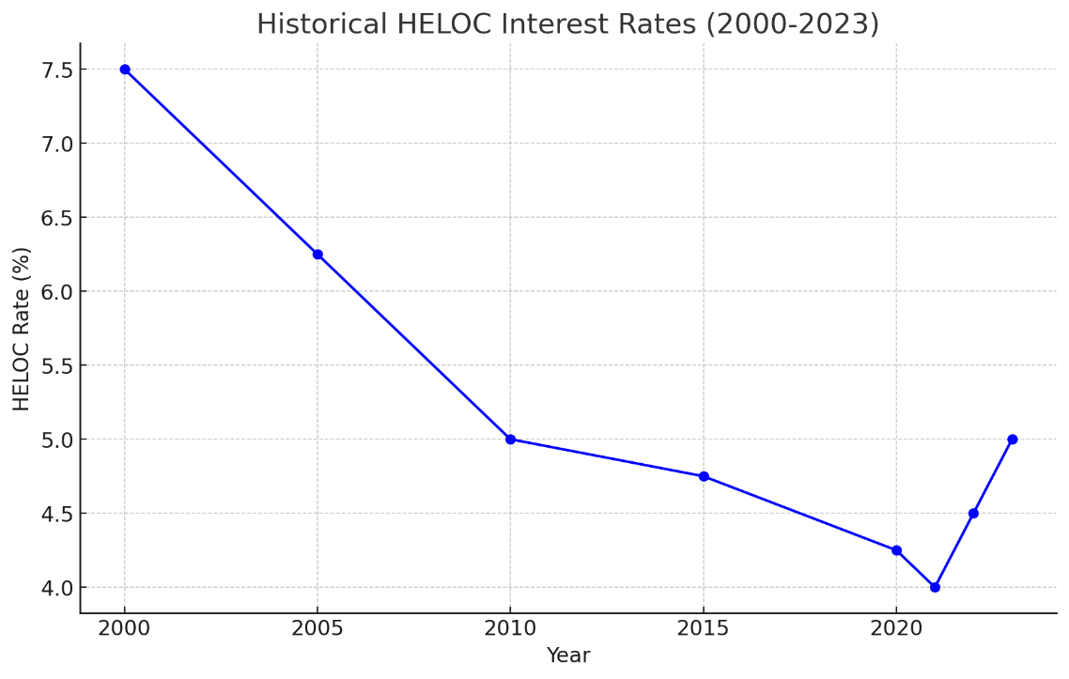

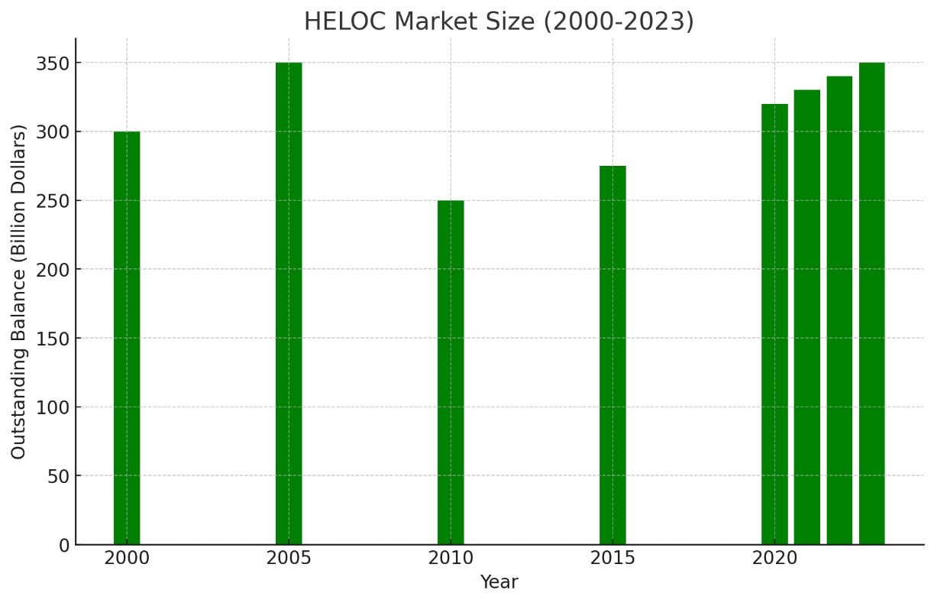

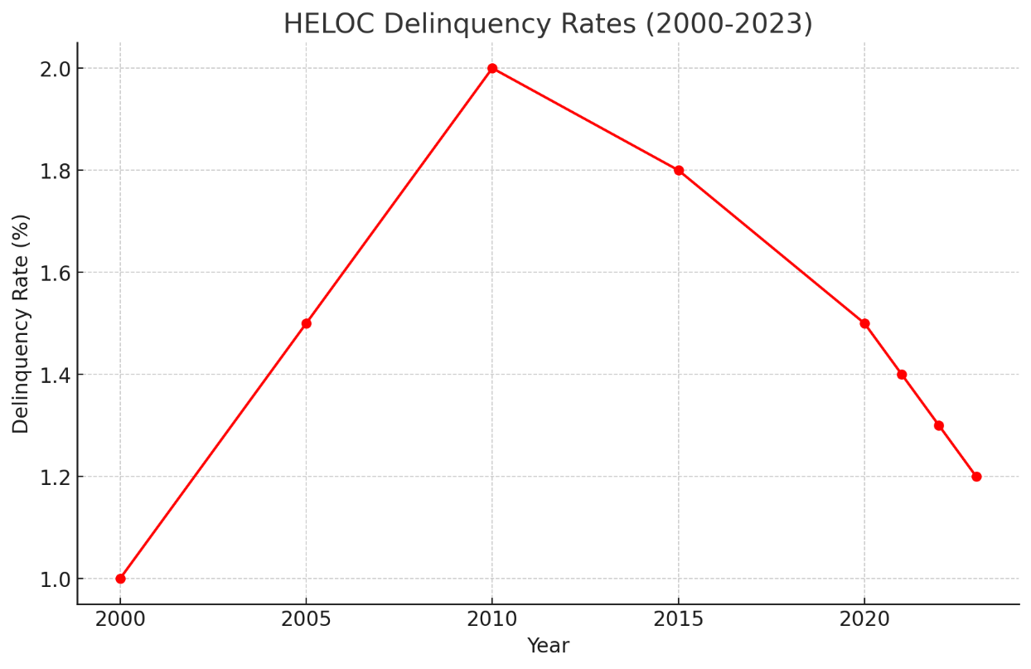

1. **Historical HELOC Interest Rates (2000-2023)**:
   * HELOC rates have fluctuated over the past two decades, with a peak of 7.50% in 2000 and a low of 4.00% in 2021. Rates have increased to 5.00% in 2023.
2. **HELOC Market Size (2000-2023)**:
   * The total outstanding balance of HELOCs has varied, reaching $350 billion in 2005, dropping to $250 billion in 2010, and then increasing again to $350 billion in 2023.
3. **HELOC Delinquency Rates (2000-2023)**:
   * Delinquency rates for HELOCs have generally remained low, with a peak of 2.0% in 2010 during the financial crisis and a gradual decrease to 1.2% in 2023.

**Key Statistics**

1. **Interest Rates**:
   * HELOC rates reached a high of 7.50% in 2000 and decreased to a low of 4.00% in 2021 before rising to 5.00% in 2023.
2. **Market Size**:
   * The outstanding balance of HELOCs peaked at $350 billion in 2005 and 2023, with a low of $250 billion in 2010.
3. **Delinquency Rates**:
   * HELOC delinquency rates peaked at 2.0% in 2010 during the financial crisis and have since declined to 1.2% in 2023.